A.I Lab Manual By Saqib Hussain

Roll No: BIT-23F-014

Python Programming Tasks (lab no 6)

**Python Loop Tasks**

**1. Basic Task: For loop to print the first 10 natural numbers**

for i in range(1, 11):  
 print(i)

Output:  
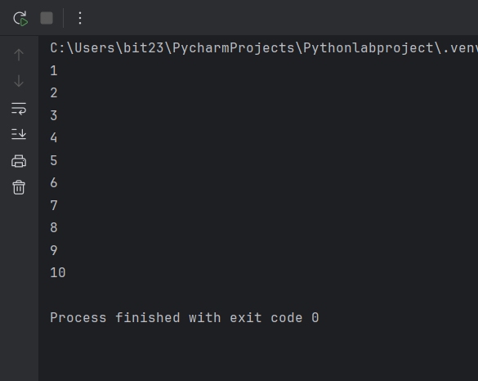

**2. Intermediate Task: While loop that prints numbers from 10 down to 1**

num = 10  
while num >= 1:  
 print(num)  
 num -= 1

Output:  
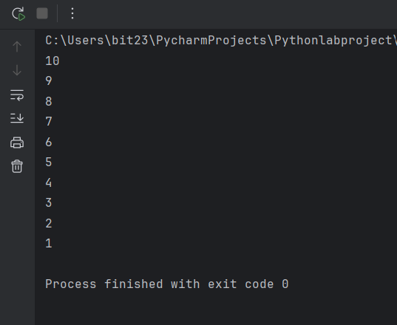

**3. Advanced Task: Count the number of vowels in a string**

text = "Hello World"  
vowels = "aeiouAEIOU"  
count = 0  
  
for char in text:  
 if char in vowels:  
 count += 1  
  
print("Number of vowels:", count)

Output:  
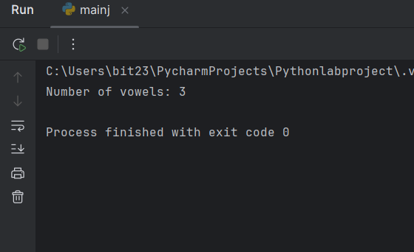

**4. Challenge Task: Fibonacci series up to n terms using a while loop**

n = 10  
a, b = 0, 1  
count = 0  
  
while count < n:  
 print(a)  
 a, b = b, a + b  
 count += 1

Output:  
